

Application Form

NEWCASTLE FUNCTIONAL SEPTORHINOPLASTY & FACIAL PLASTICS

CADAVERIC COURSE

22-24 October 2019

NEWCASTLE SURGICAL TRAINING CENTRE

NEWCASTLE UPON TYNE HOSPITALS NHS TRUST

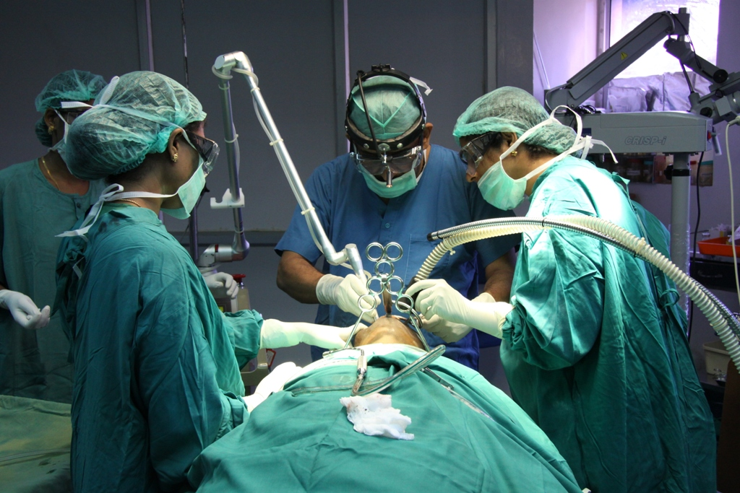

NEWCASTLE SURGICAL TRAINING CENTRE delivers over 170 advanced training courses from regional, national and international surgeons representing multi specialties. Collaboration with national and international faculty drives a greater understanding of surgical techniques delivering improved patient care. [www.nstcsurg.org](http://www.nstcsurg.org).

**Course includes**

* Anatomy
* Assessment
* Closed Approach
* Open Approach
* Osteotomy
* Nasal Grafts
* Conchal Grafts
* Rib Grafts
* Tip Surgery
* Extracorporeal Septoplasty
* Face Lift/brow lift
* Local facial flaps
* Otoplasty
* Ethnic noses (Alar base reductions)
* Nasal reconstruction

**FACULTY**

Mr. Wolfgang Issing

(Newcastle)

Mr. Mohamed Reda El Badawey (Newcastle)

Further faculty to be confirmed

Further information

For full details and registration information visit www.nstcsurg.org

Or contact: Louise Sore

Freeman Hospital, Newcastle upon Tyne

Tel: (+44) 191 24 48913

Email: [louise.sore@nuth.nhs.uk](mailto:louise.sore@nuth.nhs.uk)

**Newcastle Surgical Training Centre**



**The Newcastle Surgical Training Centre is based at the Freeman Hospital, Newcastle upon Tyne. This 3 day highly supervised course offers the opportunity to learn and enhance skills in a range of Septorhinoplasty and Facial Plastic Surgery techniques on FRESH FROZEN CADAVERS. Applicants can take advantage of intensive cadaveric teaching from an expert faculty.**

* An intensive course
* Number of attendees limited to 12
* Refreshments included
* Course certificate on completion
* Course dinner
* The course uses fresh frozen cadaveric specimens

**TARGET AUDIENCE**

ST3-ST8 and Consultants and Career Grade doctors wishing to update their skills

**Newcastle Surgical Training Centre**

Course overview

Application Form

Date:

22-24 October 2019 (3 days)

FUNCTIONAL SEPTORHINOPLASTY & FACIAL PLASTICS

CADAVERIC COURSE

|  |  |  |  |
| --- | --- | --- | --- |
|  | | | |
| **DISSECTOR FEE**: | 3 day - £950  2 day - £750  1 day - Plastics - £350 |  |  |
|  |  |  |  |
|  |  |  |  |

|  |  |
| --- | --- |
| Your details | |
| Surname: | Title: (Mr / Mrs / Miss / Ms ) |
| Forenames: | |
| Job Title: | Department: |
| Hospital Address: |  |
|  | Postcode: |
| Mobile Telephone: | Email: |

|  |
| --- |
| Further details |
| How did you hear about this course? Trust Website Mailing Other |
|  |
| Please state any special dietary requirements: |
|  |
|  |
|  |
| Please state to whom invoices should be addressed, if no alternative contact is given, all invoices  will be directed to the applicant |

|  |  |
| --- | --- |
| Declaration | |
| Signed: | Date: |

**OBSERVER FEE** 3 day - £350

2 day - £300

1 day -Plastics - £250

Course title:

     

     

     

**Please note:** The course fee will include: lunch and refreshments. Payment can be made via BACS (automatic bank transfer) by Credit Card, or by cheque payable to **Newcastle upon Tyne Hospitals NHS Trust.** Full details and registration information at [www.nstcsurg.org](http://www.nstcsurg.org) Please note payment is due at registration to secure your place. Attendance on the course is conditional upon advance payment being received. Refunds cannot be given in the event of your cancellation within two weeks of the course date. The NSTC cannot accept liability for costs incurred in the event of a course having to be cancelled as a result of circumstances beyond its reasonable control. There is an administration charge of 10% (or £50, whichever is greater) of the total course fee. However, within four weeks prior to the start date of the course, the total course fee will be charged unless in exceptional circumstances at the discretion of the NSTC.

While we make every effort to run courses as advertised, we reserve the right to change the timetable and/or the teaching staff without prior notice and to cancel any courses without liability (in which case there will be a full refund of course fees to participant). Note that any consequential losses (e.g. travel or accommodation costs) incurred in such cases remain the responsibility of the booker, and consideration should be made to taking out appropriate travel insurance for any non-refundable costs.

     